**Django GIS Poster Form Documentation**

**Introduction:**

**The purpose of this product is to automate the process of ingesting Tufts Student’s GIS Posters. The Django form allows students to enter information about their poster as well as attach a PDF of their poster. When the form is submitted, the poster is automatically saved to the correct location and the poster meta data is stored on the Django server.**

**Where the project is located:**

**This Django project is contained in the createForm folder in the S drive at this path: “S:\GIS Center Administration\Data Lab Forms\Python”.**

**Running the tool:**

1. **In order to run the tool, you need to have the following installed:**

* **Python (version 3.6.1)**
* **Django (version 1.11.6)**
* **Pillow (version 4.3.0)**
* **django-multiselectfield (0.1.8)**
* **olefile (0.44)**
* **pip (9.0.1)**
* **pytz (2017.2)**
* **setuptools (36.6.0)**
* **wheel (0.30.0)**

1. **After installing all of the above, navigate to the mysite directory under the createForm project directory (“S:\GIS Center Administration\Data Lab Forms\Python\createForm\mysite”.**
2. **Run the server locally with the following command:**

**“python manage.py runserver”**

**This should prompt the following in your terminal:**

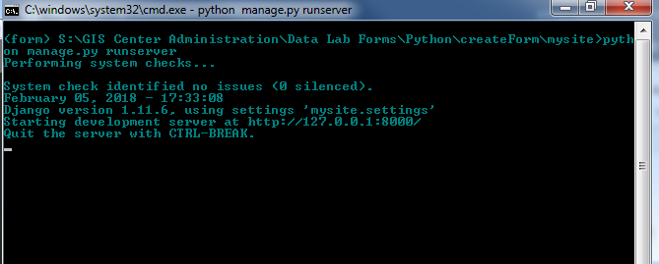

1. **Navigate to the following url path on any browser: localhost:8000/poster/new. The form should appear as follows:**

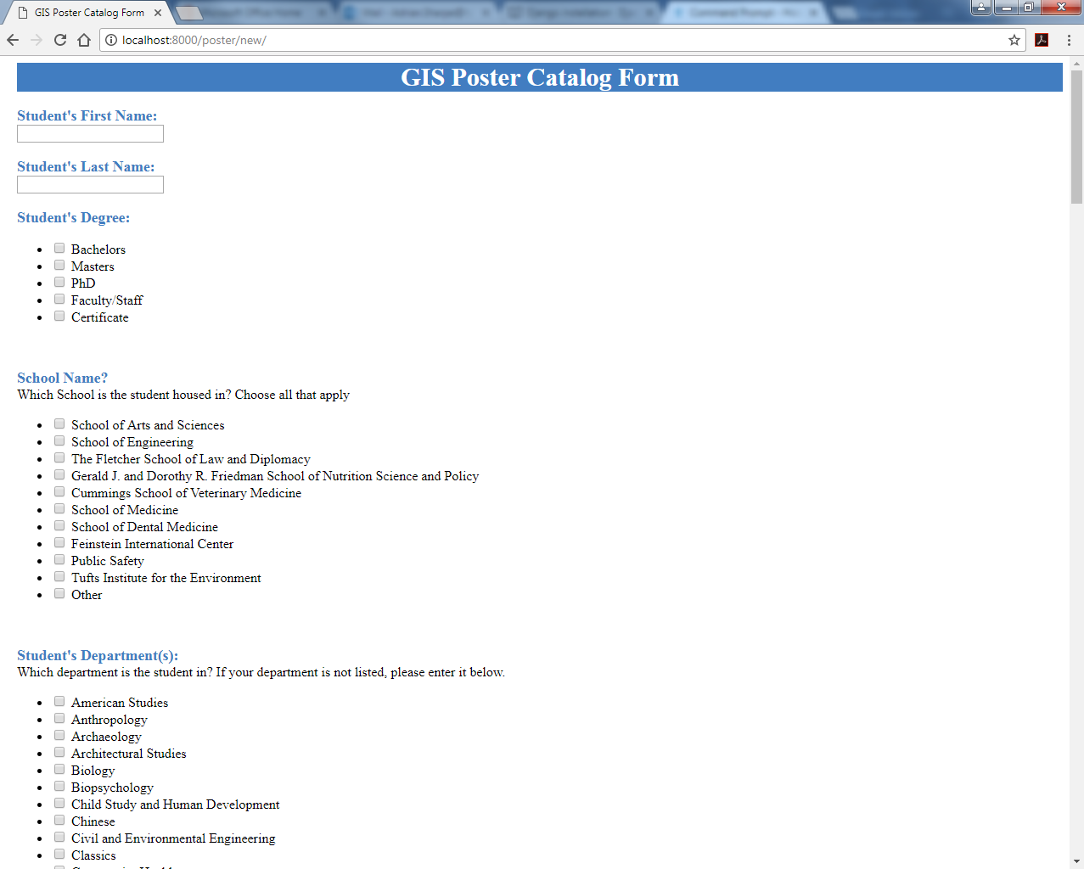

1. **After filling out a form, the user can hit submit at the bottom of the page which will direct to the following page if successfully received:**

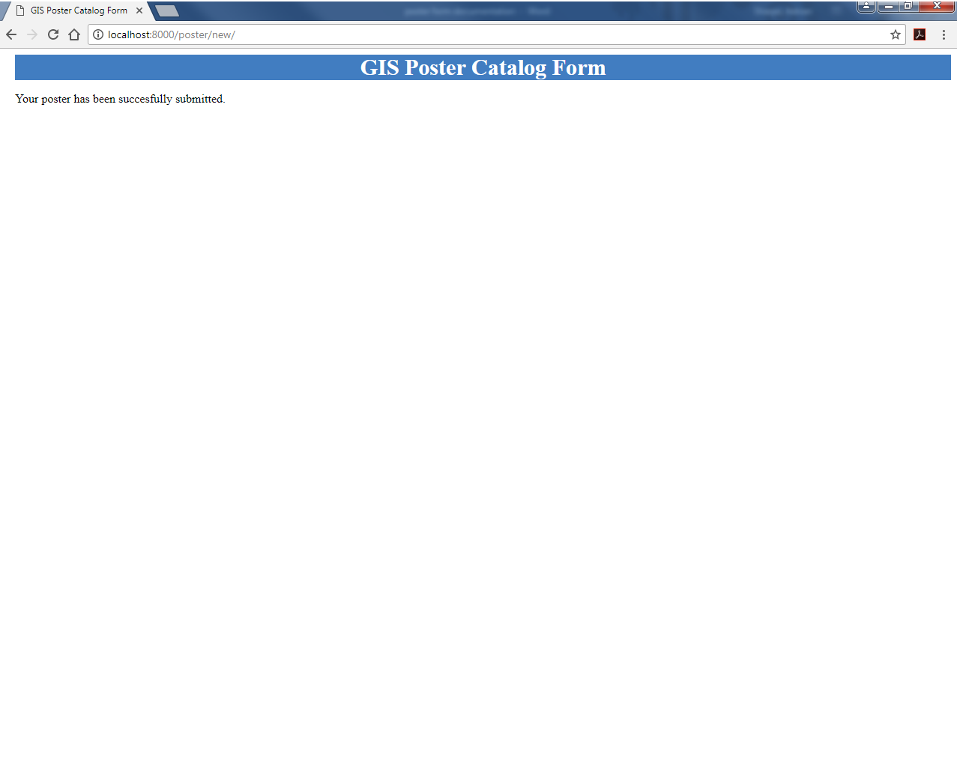

**Course form:**

**The GIS Poster model has a one-to-one relationship with the Course model. This allows any developer to add and/or update any Courses that could be potentially chosen on the GIS Poster form.   
Adding Courses to the Course database: In order for new courses to appear on the GIS Poster form, there is a separate form that can be accessed by running the server like above (step 3) and navigating to : localhost:8000/course/new**

**Admin page.**